Monday 8th – Friday 12th June
Every Day:

- Read for 15 mins.
- Irish oral work: 5 mins.
- Pick activities from the weekly work for your class: 30-45 mins.
- Reading eggs/Mathletics: 10 mins.
- Watch RTÉ Home School Hub on RTÉ 2 at 11am / ‘Cúla4 ar Scoil’ at 10.00am
- Fun for June activity of the day (See below): Record what you enjoyed or learned from each activity on your ‘Fun for June’ A3 activity sheet. Don’t forget to send us photos of how you get on!

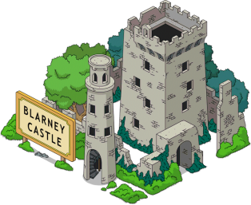
8th June
Take a virtual tour of some of Ireland’s famous landmarks https://irelandonabudget.com/virtual-tours-of-irelands-attractions/


9th June
Try some coding https://hourofcode.com/us/learn

10th June

Find a quiet space and try this visualisation called ‘The Sound of the Countryside’ https://soundcloud.com/user-547419318/the-sound-of-the-countryside-visualisation-for-children-guided-by-gerard

11th June
Learn the dance: Sid’s Shuffle
https://www.youtube.com/watch?v=uMuJxd2Gpxo
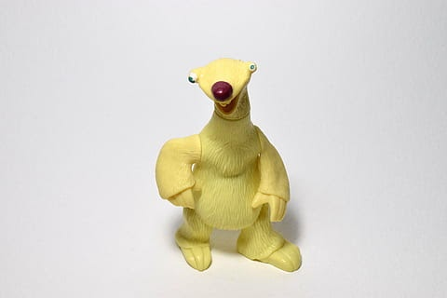
12th June

Cook something (with adult assistance)
Try out this savoury treat (Next week there will be a sweet treat for you to try out!)
https://www.youtube.com/watch?v=loRz51M4ZTE

