**Tuesday 2nd – Friday 5th June**

**ANSWERS**

**Maths:**

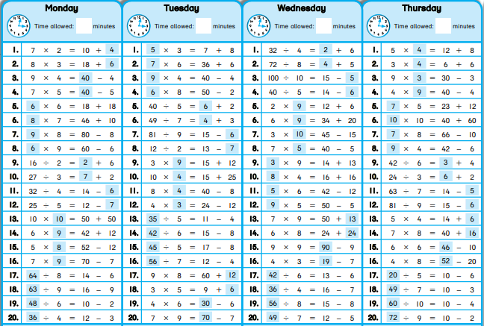 Tables: Week 30 – 5th class

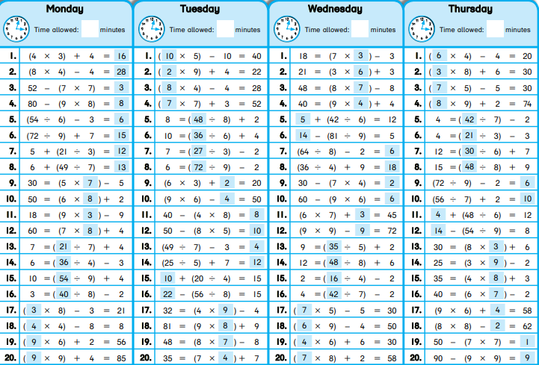6th class

Problem sheet

|  |  |
| --- | --- |
| (5th class) Length (second sheet on Length) | (6th class) Area (second sheet on Area) |
| 1. 11.08m | 1. 486cm² |
| 2. 22.315km | 2. 320cm² |
| 3. 3.815km | 3. 22m² |
| 4. 18.425km | 4. (i)5000m² (ii)50ares |
| 5. 11.725km | 5. 36m |
| 6. 2.39m | 6. 15hectares |

**English:**

Grammar sheet: The Proofreading is in the Pudding! (Pg 59)

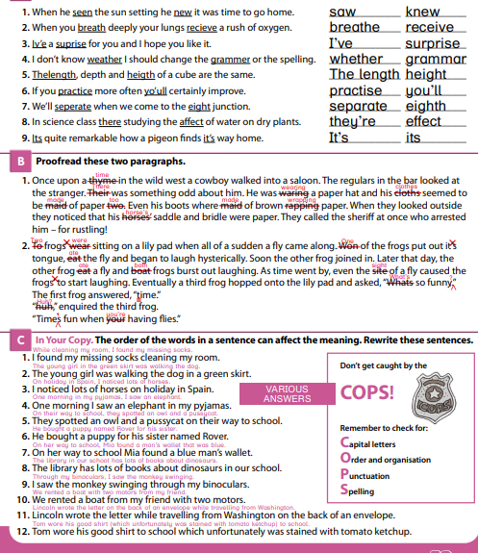

Cloze test: Television

|  |  |
| --- | --- |
| 1. in the early years | 9. by our aerials |
| 2. a Scottish engineer | 10. back to the original pictures |
| 3. two years later | 11. through the air |
| 4. in his honour | 12. over greater distances |
| 5. from a scene | 13. to news items |
| 6. into electronic signals | 14. within communities |
| 7. at the same time | 15. by young people |
| 8. to a picture tube |  |

**Gaeilge:**

Léigh sa Bhaile:

Lth. 50

1. Cleo an t-ainm atá ar an gcat.
2. Bhí sí ag rith síos Bóthar an Rí inné.
3. Tá dath glas ar a súile.
4. Tá dath bán ar a corp.
5. Leah is ainm don chailín.

Lth. 52

1. Breithlá Dhaidí a bhí ann.
2. Bhí an bhialann nua-aimseartha.
3. Bhí an tseirbhís ar fheabhas.
4. D’ith an buachaill anraith trátaí don chéad chúrsa.
5. D’ith sé lacha rósta don phríomhchúrsa.

**S.E.S.E.:**

* 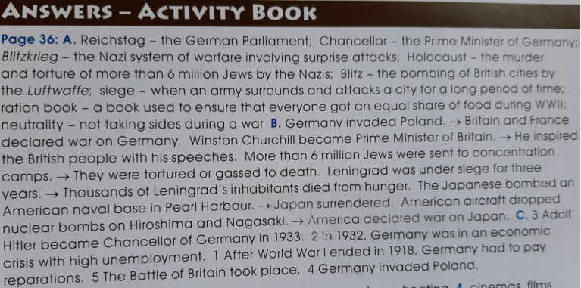Topic for week: *World War II.* SESE worksheet number 5