**2nd, 3rd and 4th Class**

**Answers for Tuesday 2nd – Friday 5th June**

**Problem Sheets**

|  |  |  |
| --- | --- | --- |
| **2nd Class** | **3rd Class** | **4th Class** |
| Review Problems 4  1) 16 adults, 80 children  2) 75c  3) 10:15, ¼ past 10  4) 4 children off the bus, 36 children on the bus  5) 5 children  6) 9 in the field now, will be 35 tomorrow  7) black sheep is 5kg heavier  8) 6 piglets  9) 14 chicks  10) 15 wheels | 7 – Money  1) €2.85  2) Sweets and Crazy Chuckles cost €2.24, so she can’t afford them.  3) He will have €0.95 left, so he can afford it  4) The gloves and ice-cream cost €1.99, so she will have €3.01 change | 7 – Weight  1) 1.93kg  2) 7kg 760g  3) 3kg 580g  4) 59kg 30g  5) 21kg 340g  6) 49kg 500g |

**Tables**

**2nd Class**

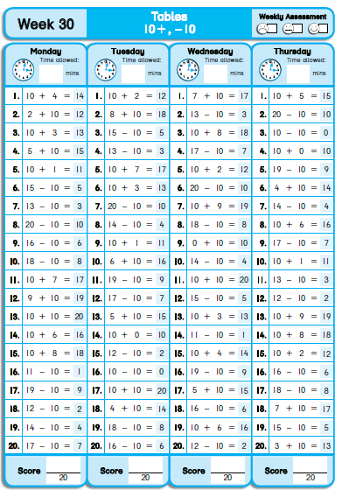

**3rd Class**

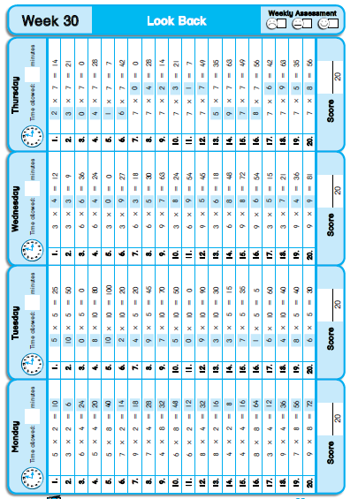

**4th Class**

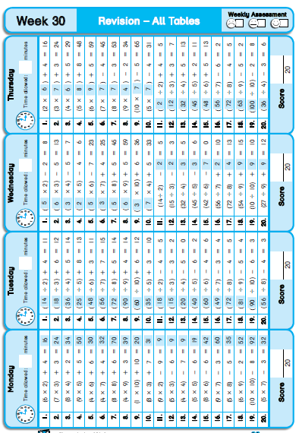

**Grammar / Phonics**

Revision

A.

1. cheetah, jaguar, lion, tiger

2. jigsaw, jet, jog, judge

3. ultra, under, upper, utter

4. flag, flee, flight, float

5. bracket, brain, brand, brave

6. threat, thrill, throw, thrush

B.

jog, judge, utter, flee, float, thrill…

C.

3. The largest butterfly is nearly 30cm.

6. Butterflies dring their food.

12. The smallest butterfly is about ½ cm.

|  |  |  |  |  |
| --- | --- | --- | --- | --- |
| **Introduction** | **Size** | **Lifecycle** | **Species** | **Food** |
| 1, 9 | 3, 12 | 8, 2, 5 | 7 | 6, 11, 10, 4 |

D.

1. sticky

2. respond

3. graceful

4. fracture

5. hazardous

6. distinct

**Cloze Test**

|  |  |  |
| --- | --- | --- |
| **2nd Class** | **3rd Class** | **4th Class** |
| The Titanic  1. large  2. and  3. Ocean  4. news  5. ship  6. Titanic  7. moving  8. It  9. The  10. not  11. 1985  12. below | Icebergs  1. water  2. the  3. can  4. Pole  5. really  6. iceberg  7. we  8. night  9. into  10. disasters  11. the  12. first  13. died  14. their  15. because  16. easily  17. tow | Jellyfish  1. makes  2. in  3. short  4. are  5. which  6. number  7. type  8. marble  9. opening  10. from  11. When  12. the  13. tentacles  14. This |

**Léigh sa Bhaile**

**Ceolchoirm na Scoile – leathanach 115**

1. Tá ceolchoirm ar siúl sa scoil anocht.

2. Tá na páistí ar bís.

3. Tá an tUasal Bairéid os comhair na soile.

4. Tá Lúsaí sa seomra ranga ag gléasadh suas.

5. Tá gach duine réidh.

**San Aerfort – leathanach 116**

1. Níor shroich an chlann an t-aerfort ar a cúig a chlog, shroich siad an t-aerfort ar a trí a chlog.

2. Rith siad ar nós na gaoithe go dtí an geata.

3. Thug Daidí na ticéid don aeróstach.

4. Ní raibh an t-eitleán réidh.

**SESE**

Light

A.

1. periscope

2. concave

3. convex

4. prism

5. spectrum

6. opaque

7. transparent

8. translucent

B.

Opaque – cardboard, tin foil, stone, woollen glove…

Transparent – empty glass, glass of water, reading glasses…

Translucent – piece of tissue, oiled piece of paper, paper towel, bubble wrap, sunglasses…

C.

Red on the outside of the rainbow, then orange, yellow, green, blue, indigo and violet