**2nd, 3rd and 4th Class**

**Answers for Monday 8th - Friday 12th June**

**Problem Sheets**

|  |  |  |
| --- | --- | --- |
| **2nd Class** | **3rd Class** | **4th Class** |
| Review Problems 5  1) 3 more children, 3 fewer adults  2) Nick weighs most, Cormac is 3rd heaviest  3) 19 people  4) 18 sausages  5) 100 litres  6) she guesses 10 less  7) €3.50  8) 2m 20cm  9) 8 o’clock | 8 – Revision  1) €1.73  2) €1.52  3) 2kg 170g  4) 1L 150ml | 8 – Money  1) €11.49  2) €2.89  3) €5.31  4) €16.44  5) €19.86  6) €38.25 |

**Tables**

**2nd Class**

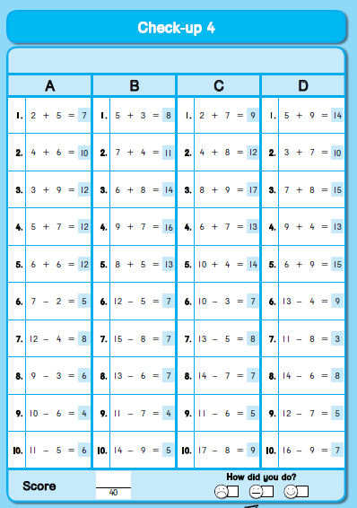

**3rd Class**

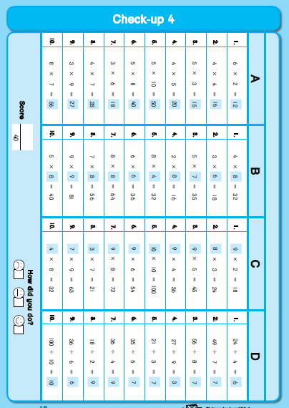

**4th Class**

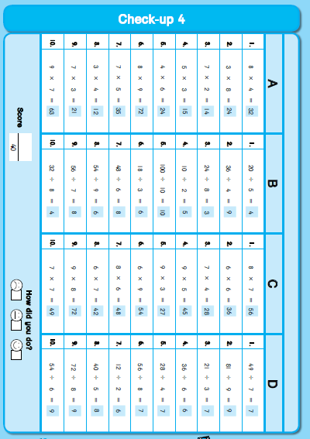

**Grammar / Phonics**

Homophones

sail – on a boat waist – around your middle

sea – the ocean weak – not strong

write – with a pencil side – at the left or right of something

nose – use it to smell toad – like a frog

new – never used before queue – a line of people

blue – the colour flew – the bird flew in the sky

sun – shines to give light heard – I heard a noise

sum – add or subtract lead – sharpen the lead in the pencil

**Cloze Test**

|  |  |  |
| --- | --- | --- |
| **2nd Class** | **3rd Class** | **4th Class** |
| Fossils  1. or  2. bones  3. comes  4. plant  5. A  6. mud  7. turns  8. fossils  9. the  10. lived | Plants that Eat Insects  1. eat  2. plants  3. take  4. ways  5. their  6. insect  7. leaves  8. until  9. caught  10. have  11. lands  12. into  13. by / into  14. with  15. away | Lucky Fall  1. a  2. her  3. gear / jacket / boots  4. off  5. wind  6. and  7. track  8. tight  9. Louise / She  10. stopping  11. fell  12. was  13. Midnight  14. stable  15. door |

**Léigh sa Bhaile**

**Pacáiste sa Phost – laethanach 117**

1. Cheannaigh Rosie éadaí ar an Idirlíon.

2. Chuala Rosie cnag ar an doras.

3. D’oscail Daidí an doras.

4. “Tá an pacáiste duit Rosie. Tá d’ainm air,” arsa fear an phoist.

5. “Tá éadaí nua do mo laethanta saoire ann,” arsa Rosie.

**Cloisim le mo Chluasa – leathanach 118**

1. Tá Susan ina suí cois trá.

2. Dúnann sé a súile.

3. Éisteann sé leis na fuaimeanna timpeall uirthi.

4. Cloiseann sí na héin ag canadh, na páistí ag spraoi agus ag gáire agus an fharraige.

5. Tá sí sona sásta leis an saol.

**SESE**

Amelia Earhart

A.

|  |  |  |  |  |  |
| --- | --- | --- | --- | --- | --- |
| 1897 AD | 1903 AD | 1912 AD | 1914 AD | 1921 AD | 1937 AD |
| Amelia Earhart is born in Kansas, USA | Wright Brothers take the first flight | *Titanic* sinks on its first transatlantic crossing | World War 1 begins in Europe | Amelia takes her first solo flight | Amelia disappears while flying around the world |

B.

1. Amelia Earhart was born

2. *Titanic* sank on its first transatlantic crossing

3. World War 1 began

4. World War 1 began

5. Amelia Earhart was born

C.

solo – to do something on your own

immigrant – person who lives permanently in another country

transatlantic – journey that involves crossing the Atlantic Ocean

navigator – person in charge of reading maps and deciding which direction to take

D.

What did you learn about Amelia Earhart? Did you discover that Amelia landed in Ireland when she flew sols across the Atlantic? Have a look at this information from the Irish Newspaper Archives <https://www.irishnewsarchive.com/wp/amelia-earhart/>

Amelia Earhart - her Irish Landing

On the 21st of May, 1932, Amelia Earhart became the first woman to fly solo, non- stop across the Atlantic. Five years previously, Charles Lindberg had achieved the trans-Atlantic crossing from New York to Paris.

Amelia Earhart left Harbour Grace, Newfoundland at 10:51pm (Irish time), Friday 20th of May, to her final destination, Paris. However, her flight was disrupted by a petrol leak and forced her to land in Ireland, “In a small field on the side of a hill overlooked by the Donegal Mountains, near Derry” (Irish Press, 23rd of May 1932) at 2 pm on Saturday.

[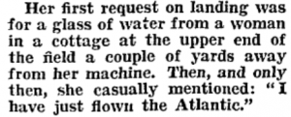](https://www.irishnewsarchive.com/ina_wp/wp-content/uploads/2015/05/First-Request.png)

As locals who saw the landing rushed to greet her and welcome her, they all noticed that she did not look tired. The owner of the field, Mr. Gallagher, also a witness to the landing, drove Miss Earhart into the city so she could use the telephone to speak to her husband. The Gallagher family was her host for the night.

[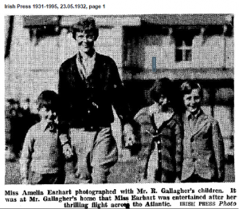](https://www.irishnewsarchive.com/ina_wp/wp-content/uploads/2015/05/photo-with-Gallagher-kids.png)

E.

Amelia was a pioneer – she was willing to try new things, she pushed boundaries to break a record and overcame challenges to experience success. What did you learn about other pioneers?