**2nd, 3rd and 4th Class**

**Answers for Monday 25th – Friday 29th May**

**Problem Sheets**

|  |  |  |
| --- | --- | --- |
| **2nd Class** | **3rd Class** | **4th Class** |
| Review Problems 3  1) 1000 paperclips  2) 10 o’clock  3) 50c  4) 20 people  5) €2.50  6) 38kg  What am I? 43 | 6 – Capacity  1) 2L 260ml  2) 1L 250ml  3) 4L 520ml  4) 1L 170ml | 6 – Length  1) 18km 140m  2) 1km 810m  3) 10km 260m  4) 2km 420m  5) 87cm  6) 16km 940m |

**Tables**

**2nd Class**

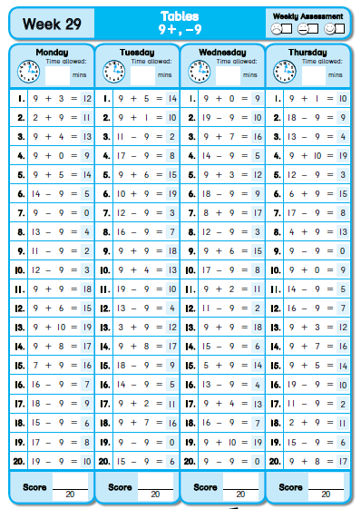

**3rd Class**

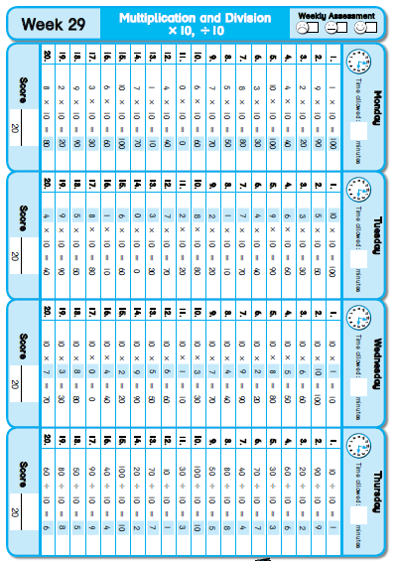

**4th Class**

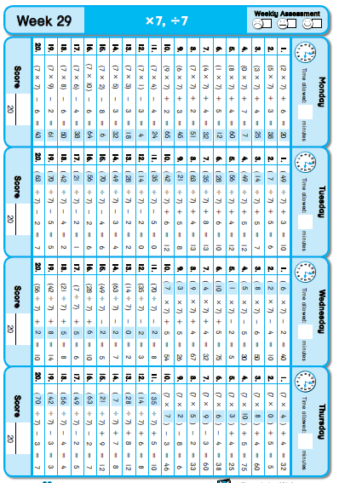

**Grammar / Phonics**

Revision – Suffix: _tion, _sion, _ssion and _cian

1. Addition 2. decision

3. Subtraction 4. Vacation

5. question 6. attention

7. directions 8. invitation

9. decorations 10. expression

11. optician 12. admission

13. occasion 14. television

15. musician

**Cloze Test**

|  |  |  |
| --- | --- | --- |
| **2nd Class** | **3rd Class** | **4th Class** |
| Koalas  1. called  2. pouch  3. koalas  4. a  5. proper  6. Australia  7. or  8. Koalas  9. claws  10. branches  11. they  12. of  13. the  14. hours  15. an  16. get  17. leaves | Patterns and Numbers in Nature  1. Patterns  2. hive  3. snowflake  4. butterfly  5. tigers  6. leopards  7. scientists  8. angelfish  9. stripes  10. cockroach  11. legs  12. speeds  13. ground  14. animals  15. numbers | The Water Tank  1. lives  2. many  3. rain  4. house  5. water  6. Sarah  7. tap / water  8. bath  9. washing  10. empty  11. delivered  12. day  13. into  14. through  15. rained |

**Léigh sa Bhaile**

**Éadaí Samhraidh – leathanach 112**

1. Bhí Mamaí ag déanamh na siopadóireacht ar an Idirlíon.

2. Bhí éadaí ag teastáil do no laethanta saoire.

3. Cheannaigh siad dhá chulaith shnámha, sé T-léinte agus cúig ghúna.

4. “Sin an tsiopadóireacht críochnaithe!” a dúirt Mamaí.

5. Mhúch sí an ríomhaire.

**Sa Samhradh – leathanach 113**

1. Bíonn an aimsir go maith sa samhradh.

2. Bíonn an ghrian at taitneamh.

3. Bíonn duilleoga ar na crainn.

4. Téann daoine cois trá.

5. Téann daoine ar saoire.

**Mála Taistil – leathanach 114**

1. Bhí ma páistí ar bís.

2. Bhí siad ag du lar a gcuid leathanta saoire.

3. Ní raibh siad ag pacáil le Daidí, bhí siad ag pacáil le Mamaí.

4. Chuir Roas dhá chulaith shnámha isteach sa mhála taistil.

5. Chuir Daidí an mála taistil sa charr.

**SESE**

Caring for the Sick

A.

|  |  |  |  |  |  |
| --- | --- | --- | --- | --- | --- |
| 460 BC | 600 BC | 1340 AD | 1821 AD | 1861 AD | 1928 AD |
| Hippocrates is born | Celts use plants and herbs to cure illness | Black Death hits Dublin | Cholera outbreak in Dublin | Louis Pasteur discovers bacteria | Alexander Fleming discovers penicillin |

B.

trepanning – cutting a hole in the skull to release bad spirits that caused disease

tenements – large houses owned by wealthy people and rented to poor families

penicillin – type of mould that grows on food that has gone bad

Hippocratic Oath – oath sworn by doctors to do everything in their power to help patients

diagnose – to identify a disease based on its symptoms

antibiotic – medicine used to fight the bacteria that cause infection

C.

screwdriver – no scalpel – yes hammer - no wrench spanner – no syringe - yes

tin opener – no thermometer – yes fork – no otoscope – yes stethoscope - yes

D.

Do you think Alexander Fleming’s discovery helped to change the course of history?

I believe it did – I would like to tell you about my Great Auntie Louise. She was born in 1922, and when she was a young girl she got a cut on her foot. The cut got infected and didn’t heal – Louise had to have her leg amputated at her knee because doctors didn’t have any antibiotics to treat the infection in her foot. If my Auntie Louise had been born a few years later, after Alexander Fleming had discovered penicillin, doctors would have been able to treat the infection and she probably wouldn’t have had to have her leg amputated. (My Auntie Louise had an artificial leg – she loved baking and gardening, and lived until she was 91 – so although her life was changed because there was no penicillin, she had a very happy life!)