**Tuesday 5th – Friday 8th May**

**ANSWERS**

**Maths:**

Tables: Week 26

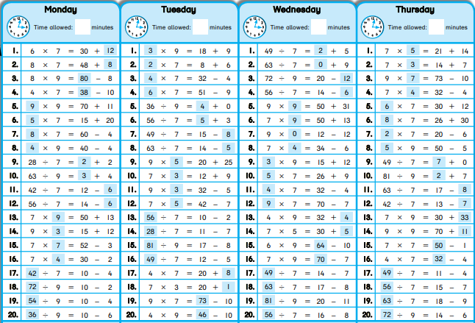5th class

6th class

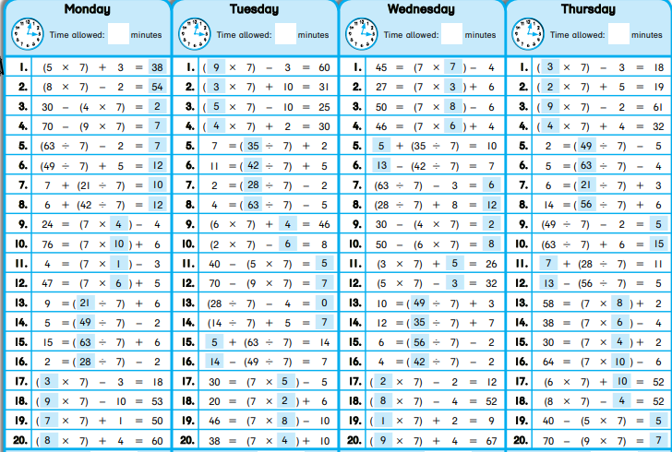

Problem sheet

|  |  |
| --- | --- |
| (5th class) Area & Perimeter (second sheet on Area & Perimeter) | (6th class) Length (second sheet on Length) |
| 1. 448m² | 1. 19.25km |
| 2. 578m² | 2. 114km |
| 3. €864 | 3. 83.955km |
| 4. 512m² | 4. 7.9cm |
| 5. €960 | 5. €12.35 |
| 6. €588 | 6. 189km |

**English:**

Grammar sheet: Pass the Participle (Pg 48)

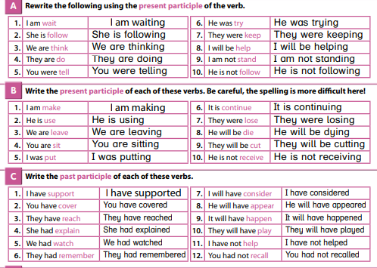

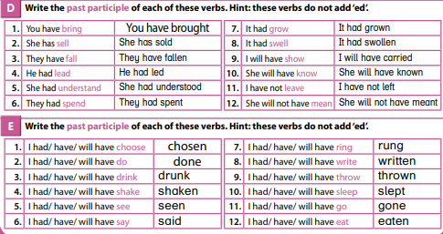

Cloze test: The Solar System

|  |  |  |
| --- | --- | --- |
| 1. is | 2. Solar | 3. a |
| 4. travel | 5. moons | 6. centre |
| 7. times | 8. put | 9. the |
| 10. over | 11. planets | 12. Sun |
| 13. and | 14. the | 15. rock |
| 16. a | 17. Jupiter | 18. left-over |
| 19. of | 20. are | 21. tail |
| 22. or |  |  |

**Gaeilge:**

Léigh sa Bhaile:

Lth. 33

1. Bhí Niamh agus a Mamaí sa seomra feithimh.
2. Dúirt an fáilteoir go mbeadh sí ceart go leor.
3. Chuaigh Mamaí in éineacht le Niamh.
4. Dúirt an fiaclóir, “Suigh síos agus ná bíodh imní ar bith ort.”
5. Thug sé instealladh di.

Lth. 34

1. Bhí an cailín aon bhliain déag d’aois.
2. Níor thug a múinteoir obair bhaile di.
3. Rinne Mamaí cáca breithe di.
4. Bhí dioscó ar siúl sa gharáiste.
5. D’imigh a cairde abhaile ar a sé a chlog.

**S.E.S.E.:**

* Topic for week: *Revolution and Independence.* SESE worksheet number 1.

