**Monday 11th – Friday 15th May**

**ANSWERS**

**Maths:**

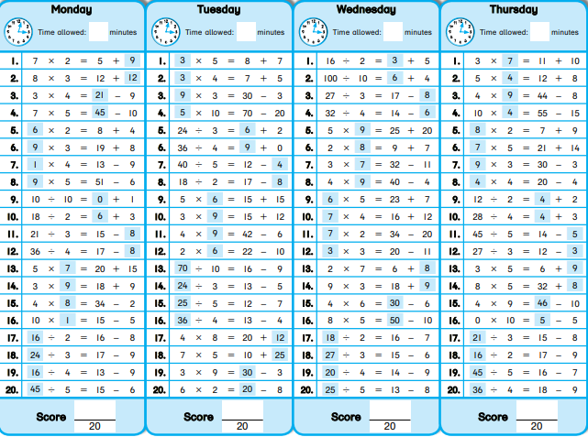Tables: Week 27 – 5th class

6th class

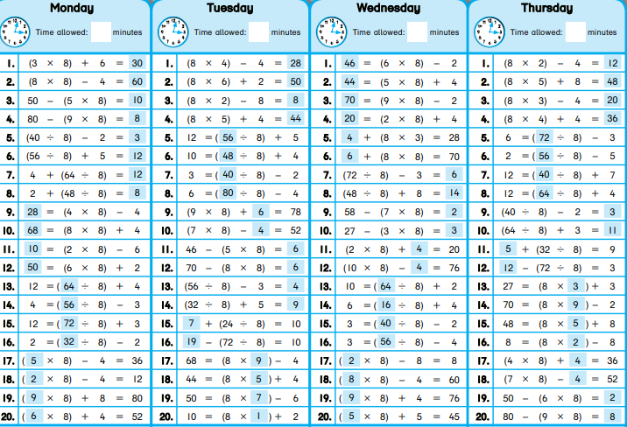

Problem Sheet

|  |  |
| --- | --- |
| (5th class) Money | (6th class) Time |
| 1. €7.65 | 1. 2hrs 40mins |
| 2. €19.50 | 2. 2hrs 35mins |
| 3. €16.45 | 3. 5hrs 28mins |
| 4. 36c | 4. 2hrs 27mins |
| 5. €5.85 | 5. €700 |
| 6. €936 | 6. 180km |

**English:**

Grammar sheet: Parts of Speech (Pg 54)

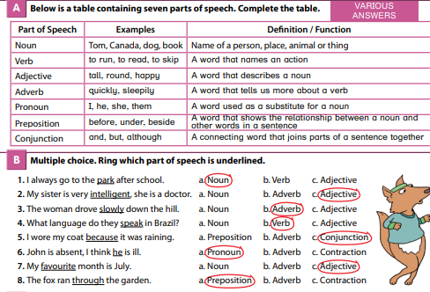

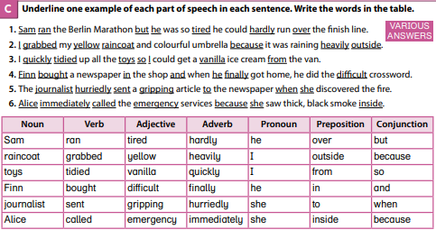

Cloze test: Communications History

|  |  |  |
| --- | --- | --- |
| 1. different | 2. earliest | 3. flat |
| 4. long | 5. dense | 6. carved |
| 7. coloured | 8. short | 9. polished |
| 10. worldwide | 11. modern | 12. human |
| 13. electrical | 14. glass | 15. original |

**Gaeilge:**

Léigh sa Bhaile:

Lth. 37

1. Bhí an chlann ar laethanta saoire i Liospóin.
2. Bhí siad ag fanacht in óstán ar bharr cnoic.
3. Fuair siad an tram síos go dtí an tsráid siopadóireachta.
4. Chuaigh an tram an-tapaidh.
5. Nuair a bhí siad críochnaithe, fuair siad an tram suas an cnoc arís chuig an óstán.

Lth. 38

1. Chuaigh James agus Saoirse ar shiúlóid.
2. Shéid an ghaoth hata James óna cheann.
3. Thit an hata isteach san fharraige.
4. Phioc an fear amach an hata agus thug sé ar ais do James é.
5. Bhí James sona sásta.

Lth. 39

1. Bhí Mamaí ag iarraidh cistin nua sa teach.
2. Roghnaigh sí tíleanna nua, cuntair nua, oigheann nua agus páipéar balla nua.
3. Bhí na tógálaithe sa teach ar feadh coicíse.
4. Bhí an teach trína chéile.
5. Tá sé críochnaithe.

**S.E.S.E.:**

* Topic for week: *Study of a Bogland Area.* SESE worksheet number 2.

