**2nd, 3rd and 4th Class**

**Answers for Tuesday 5th – Friday 8th May**

**Problem Sheets**

|  |  |  |
| --- | --- | --- |
| **2nd Class** | **3rd Class** | **4th Class** |
| Measures Problems 1  1) 12kg  2) 100kg  3) 9:00  4) 9kg  5) 100g  6) 3:00  What am I? 11 o’clock | 3 – Money  1) €2.05  2) €4.03  3) 11c  4) Yes – they cost €2.87 | 3 – Revision  1) €17.46  2) 11 bags, 6 plums left  3) 57 chocolates  4) 81 apples  5) 164  6) 68 empty seats |

**Tables**

**2nd Class**

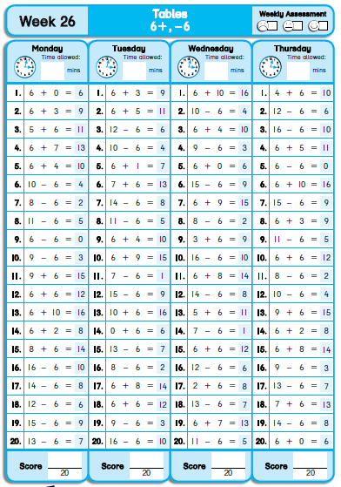

**3rd Class**

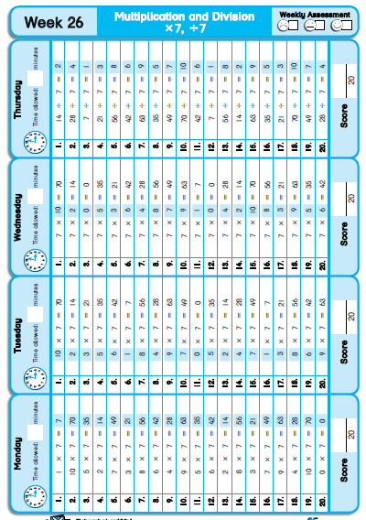

**4th Class**

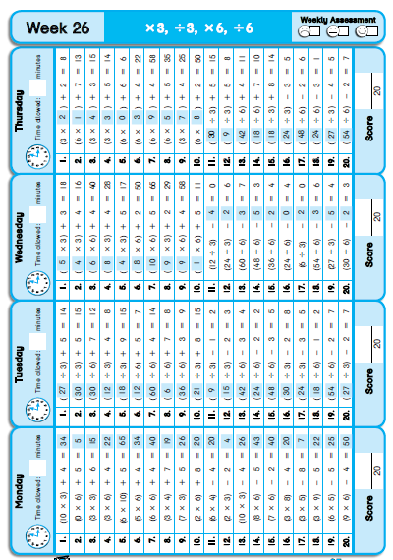

**Grammar / Phonics**

Suffix: _sion and _ssion

A. B. C.

vi sion ex ten sion app re hen sion

ten sion co lli sion comp re hen sion

ses sion ex plo sion tel e vi sion

D. discussion

expression expansion

aggression diversion

permission suspension

E. occasion

invasion diversion

revision extension

confusion explosion

**Cloze Test**

|  |  |  |
| --- | --- | --- |
| **2nd Class** | **3rd Class** | **4th Class** |
| Water Wisdom  1. clouds  2. rivers  3. water  4. are  5. dishes  6. used  7. Dirty  8. into  9. wisely  10. Some  11. shorter  12. garden | Braille  1. blinded  2. learnt  3. feel  4. taught  5. invented  6. used  7. stood  8. typed  9. changes  10. died | The Water Cycle  1. water  2. oceans  3. land  4. river  5. treatment  6. homes  7. drains  8. sewage  9. oceans  10. sun  11. vapour  12. clouds  13. droplets  14. rain  15.cycle |

**Léigh sa Bhaile**

**An Deireadh Seachtaine – leathanach 104**

1. Beish leadóg ar siúl maidin Dé Sathairn.

2. Beidh ranganna snámha ar siúl sa tráthnóna.

3. Beidh cóisir lá breithe ar siúl oíche De Sathairn.

4. Beidh cispheile ar siúl maidin Dé Domhnaigh.

5. Beidh cluiche peile ar siúl um thráthnóna.

**SESE**

Forces

Were your predictions correct?

I predict the car will move the most, the then crayon. I don’t think the rubber or sponge will move very much, particularly at the low levels – if your ramp is very steep, they might!

Did you keep the tests fair by keeping the surface of the ramp the same each time and making sure that you didn’t push any of the objects harder than the others?

We observed that the height of a ramp affects movement.