**2nd, 3rd and 4th Class**

**Answers for Monday 18th – Friday 22nd May**

**Problem Sheets**

|  |  |  |
| --- | --- | --- |
| **2nd Class** | **3rd Class** | **4th Class** |
| Review Problems 2  1) 100 children  2) €9  3) 56cm  4) 3:30, half past 3  5) 6 ducks  6) €47  What am I? 9 | 5 – Length  1) 4m 52cm  2) 58cm  3) Martin walked 6m 6cm, Kevin walked 4m 82cm, so Martin walked 1m 24cm further  4) 9m 95cm | 5 – x and ÷  1) 2064 pages  2) 3648 pages  3) 3995 oranges  4) 9744 papers  5) 9486  6) 49 stamps |

**Tables**

**2nd Class**

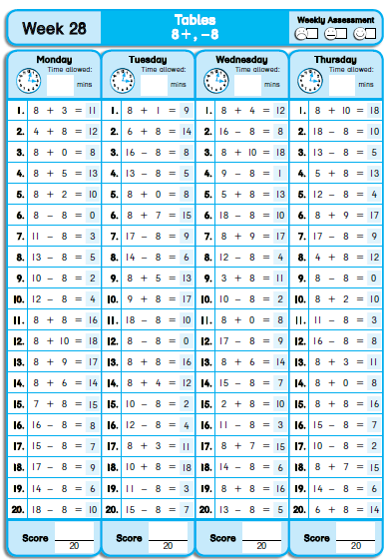

**3rd Class**

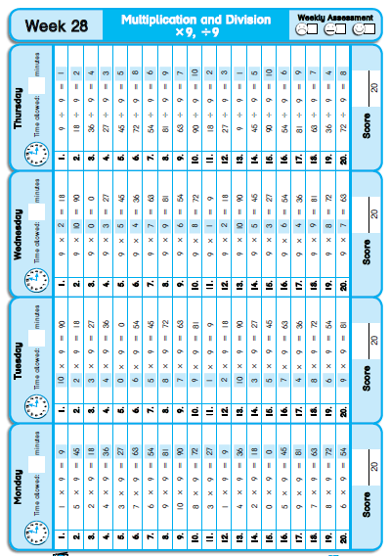

**4th Class**

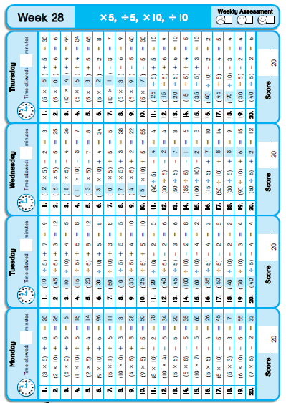

**Grammar / Phonics**

Suffix: _cian

1. electrician

2. magician

3. dietician

4. technician

5. beautician

6. politician

7. optician

8. musician

9. mathematician

Did you notice that these are all jobs?

**Cloze Test**

|  |  |  |
| --- | --- | --- |
| **2nd Class** | **3rd Class** | **4th Class** |
| Whales  1. live  2. mammals  3. air  4. milk  5. and  6. fish  7. called  8. cold  9. Winter  10. breathe  11. minutes  12. hour | Islands  1. smaller  2. come  3. a  4. Australia  5. is  6. is  7. one-third  8. different  9. a  10. be  11. when  12. rub  13. Some  14. years  15. mainland  16. examples  17. wild | Writing  1. pictures  2. sounds  3. tribes  4. drew  5. stood  6. crown  7. invent  8. arranged  9. Greek  10. second |

**Léigh sa Bhaile**

**An Samhradh – leachanach 109**

1. Tá an samhradh tagtha.

2. Beidh an ghrian ag spalpadh.

3. Níl scoil ag aon duine.

4. Tá na páistí ar bís.

5. Beidh uachtar reoite acu don dinnéar.

**Clár Taistil – leathanach 110**

1. An Aoine a bhí ann.

2. Bhí Mamaí ag breathnú ar chlár taistil.

3. Thaispeáin siad an Spáinn agus an Frainc sa chlár.

4. “Féach ar na laethanta sacoire áille,” a dúirt Mamaí.

5. “Ar mhaith leat dul ag campáil sa Fhrainc?” a dúirt Daidí.

**Saoire ar an Idirlíon – leathanach 111**

1. Siopa Taistil Tassie is ainm don siopa.

2. Tá saoirí san Iodáil, san Algarve agus sa Fhrainc ar sladmhargadh.

3. Cliceáil ar an mbosca chue é a chur in airithe.

4. Cuir glaoch ar Tassie gcomhair breis eolais ar 053-21112873.

**SESE**

Materials and Change

A.

1. Solids are shapes with a definite shape – it will not change shape unless force is applied to it. The particles in a solid are stuck closely together.

2. A liquid is a material that can flow and change shape to fit the container into which it is poured. The particles are close together, but move around each other easily.

3. Heat moves through some solids by the process of conduction, for example the bottom of a saucepan.

4. You should have insulation in the attic to stop heat escaping through the rood of your house.

5. Salt will dissolve in water – we can separate the salt from the water again by evaporating the water.

B.

All materials are made up of tiny particles called atoms and molecules. Materials may be solid, liquid or gas. A solid is a material with a definite shape. The particles in a solid are stuck close together. Anything that you can take hold of is a solid. The particles in a liquid can move around each other easily. A liquid can flow. It changes shape to fit the container into which it is poured. The particiles in a gas have no definite shape. They move quickly, spreading out in all directions.

C

1. oven gloves, saucepan handle, tea cosy, flask, coasters…

2. element in kettle, radiator, base of saucepan, bottle warmer…