**2nd, 3rd and 4th Class**

**Answers for Monday 20th – Friday 24th April**

**Problem Sheets**

|  |  |  |
| --- | --- | --- |
| **2nd Class** | **3rd Class** | **4th Class** |
| Weight Problems 1  1) 13kg  2) 7kg  3) 500g  4) 37g  5) 4 bags  6) 8kg  What am I?  76kg / 77kg / 78kg / 79kg | 1 – Length  1) 5m 62cm  2) 1m 9cm  3) 6m 42cm  4) 1m 13cm | 1 – x  1) 152 pages  2) 82  3) 93  4) 288 apples  5) 35 stamps  6) 140 |

**Tables**

**2nd Class**

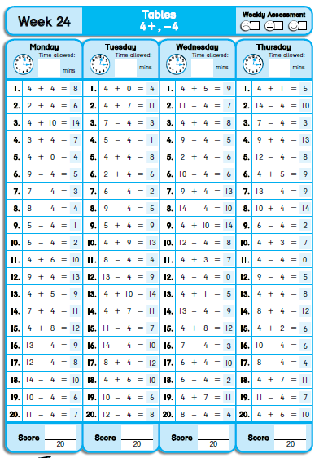

**3rd Class**

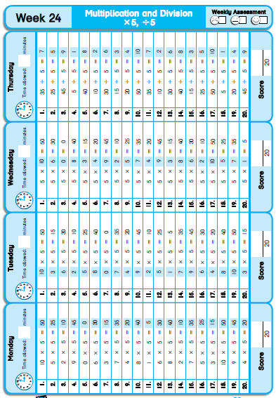

**4th Class**

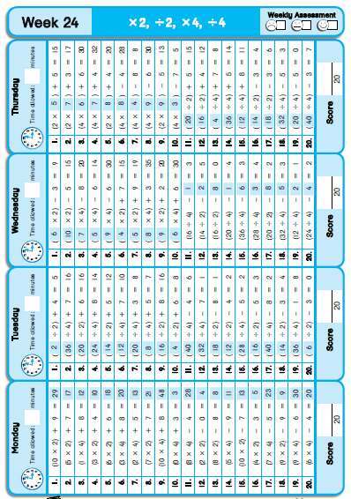

**Grammar**

Thesaurus Text!

A.

1. wet – damp, humid, moist, rainy, watery…

2. old – aged, ancient, elderly, mature, antique…

3. sad – depressed, gloomy, unhappy, glum, tragic…

4. cold – chilly, cool, freezing, frozen, icy…

5. small – little, miniature, tiny, miniscule, petite…

B.

It was a freezing wintry day. Sarah leaped from her bed and ran to the window, enthusiastic to see if it had snowed during the night. A thick blanket of snow covered the ground outside her window. Sarah ran downstairs and asked her brother Tom, “Would you like to come outside and build a snowman?” “I would love that,” he said.

The two children marched outside, delighted that they had no school and could spend the day playing in the snow.

Sarah began rolling the snow into a ball to make the snowman’s body. Then they rolled a little ball of snow for the head. Tom was messing and accidentally knocked the head off. Sarah was really cross and began yelling at him. Tom started to weep, “I’m so sorry,” he said. Sarah felt bad for shouting and told Tom it was OK, they could fix the snowman.

Together they completed the snowman, adding a scarf, hat, eyes and a mouth. “Oh no!” cried Tom. “We forgot his nose. I’ll go and get a carrot, stay here.” Tom raced off, returning a few minutes later with a huge carrot. Sarah placed it in the centre of the snowman’s face. Sarah and Tom stood and gazed at the snowman, enormous grins spreading across their faces. It had been a fantastic day.

(It is fine if you used different words, as long as the meaning is the same!)

How many synonyms for **big** did you think of? Did you get more than 10? or more than 20? Well done if you did!

**Cloze Test**

|  |  |  |
| --- | --- | --- |
| **2nd Class** | **3rd Class** | **4th Class** |
| Penguins  1. fly  2. funny  3. can  4. southern  5. covered  6. act  7. webbed  8. can  9. waterproof  10. keep  11. their  12. catch  13. the  14. look  15. make  16. rookery | Elephants  1. types / kinds  2. elephant  3. trunks  4. with / through  5. water  6. is  7. makes  8. made  9. tusks  10. used  11. are  12. and  13. of  14. carry  15. their | Ships through the ages  1. open  2. dangerous  3. different  4. bigger  5. valuable  6. successful  7. wooden  8. underwater  9. iron  10. lucky |

**Léigh sa Bhaile**

**Moncaí agus an Banana – leathanach 94**

1. Lábreá grianmhar a bhí ann.

2. Chuaigh Ava agus Holly go dtí an zú.

3. Bhí na moncaithe taobh thiar dóibh.

4. Bhí banana ag Holly.

5. Thóg an moncaí an banana agus d’ith sé é.

**Am Lóin – leathanach 97**

1. Tá sé in am loin. / Am lóin atá ann.

2. Níl Lúsaí ceart go leor. Rinne sí dearmad ar a bosca lóin.

3. Níl aon rud aici.

4. Tá cairde cineálta ag Lúsaí.

**Bróga Peile Nua – leathanach 99**

1. Tá Cian ag dul siopadóireacht le Mamaí.

2. Tá bróga peile uaidh.

3. Tá bróga peile sa vardrús.

4. Níl said rómhor, tá said róbheag.

5. Níl a fhois ag Cian cé mhéad a bheidh orthu.

**SESE**

I hope you enjoyed completing your project on the Vikings. We would love to see your Art work and finished projects – if you would like to take a photograph of your project and email it to the school, we will post pictures of your amazing work on the website.